17. Implementing full text search functionality in a database.

create database Job_Portal3;
use Job_Portal3;

create table jobs1 (
job_id int auto_increment primary key,
title varchar(225),
description text,
location varchar(100),
fulltext(title,description)
);

insert into Jobs1(title,description,location) values
('Software Developer', 'Looking for a developer skilled in Java,Spring Boot, and MySQL','bangalore'),
('Data Analyst','Analyze data using Python,SQL,and Power BI','Mumbai'),
('Full Stack Engineer','React and Node.js developer required for web development','Remote'),
('Database Administrator','Manage MSQL databases and optimize performance','Delhi'),
('Python Developer','Backend Python developer with experience in Django','Pune');
select*from Jobs1

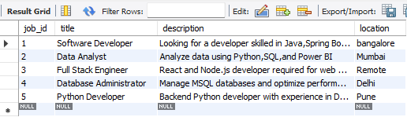
select*from Jobs1
where match(title,description)against('python developer' in natural language mode);

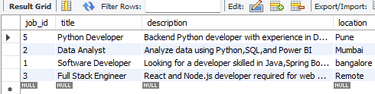

select*from Jobs1
where match(title,description)against('+python +Django-Java'in boolean mode);

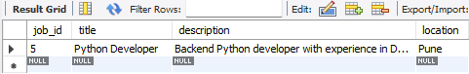

alter table jobs1 add fulltext(title, description);
set @search='MySQL developer';
select*from Jobs1
where match(title,description)against(@search in natural language mode);

